Assignment for **Oracle E- Business Suite Inventory**

Date:15th Nov-2024

[Provide screenshots of each step (which performed in a live environment).  
As evidence all the activity screens shot needs to be attached]

1. What is the Oracle Inventory module?

This is part of the Oracle E-Business Suite. It provides features for managing items, inventory levels, sub-inventories, transactions, and integration with other modules like Order Management and Purchasing

To get here I would just have to click on Items > Master Items and then in the Navigation I have to go to Vision Operations.

2.With you User id switch to: **Vision Operation Inventory**. Responsibility.

3.Choose **VI Inventory Org & Find the master Items.**

To get here I would just have to click on Items > Master Items > and then in the Navigation I have to go to Vision Operations then once the master item screen comes up I have to go to the inventory section.

4.Take any Item & assign the same Item for all the **Inventory Org.**

Once I would query the table, I then would select the organization Tab on the left and select assign all.

5. And Un assign the same Item for all the **Inventory Org.**

To un assign the items I would press the unassign all button at the bottom of the master items.

6**.** Any of the existing Item [VI Inventory org] Check the on-hand quantity.

To get here I would simply go from Inventory > On-Hand Availability > On Hand Quantity Then navigate to Vision Operations

7. Unit of Measure (UOM)... with Navigation show where UOM has been defined.

I would go from Inventory > Setup> Units of Measure > Units of Measure

I would get here after I select Vision Operations in the navigation

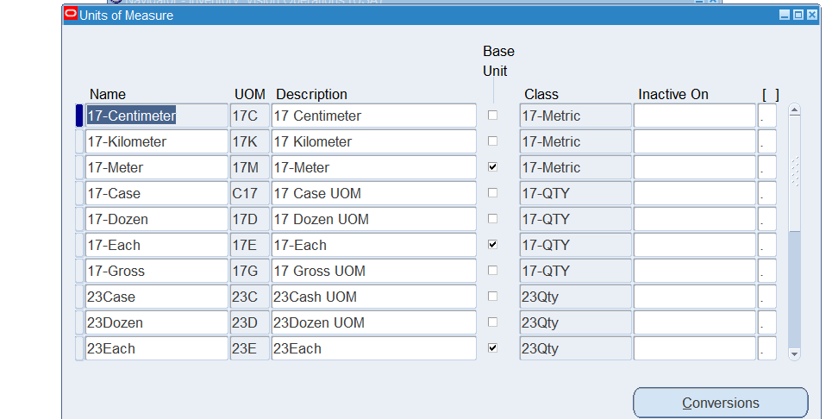

8. How do you create a new inventory item?

I would go to Inv > Items> Master Items, Navigate to Vision Operations. Once I would do that, I fill out the Master Item window and then save it.

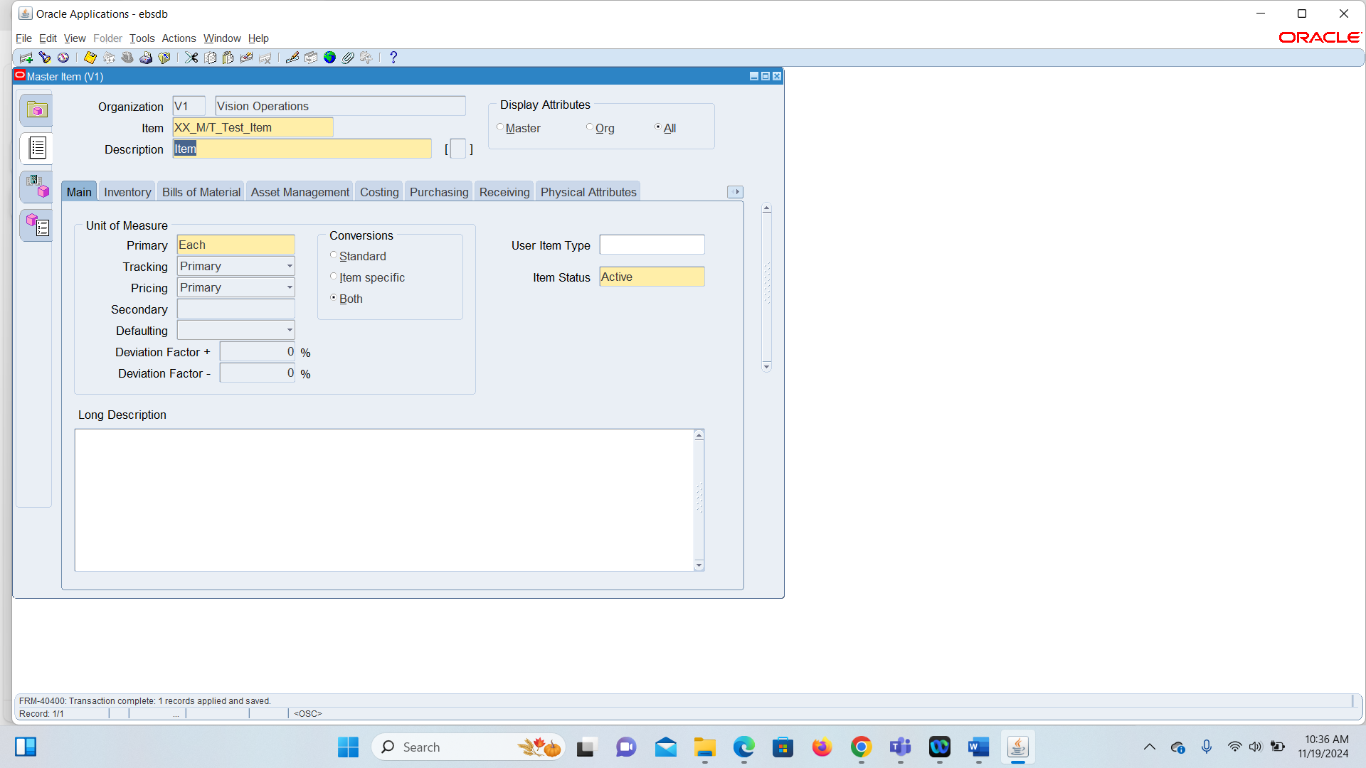

9. How to run Inventory Valuation Report?

I would Go to View > Requests

Once I get here I put 1 for the Exchange rate

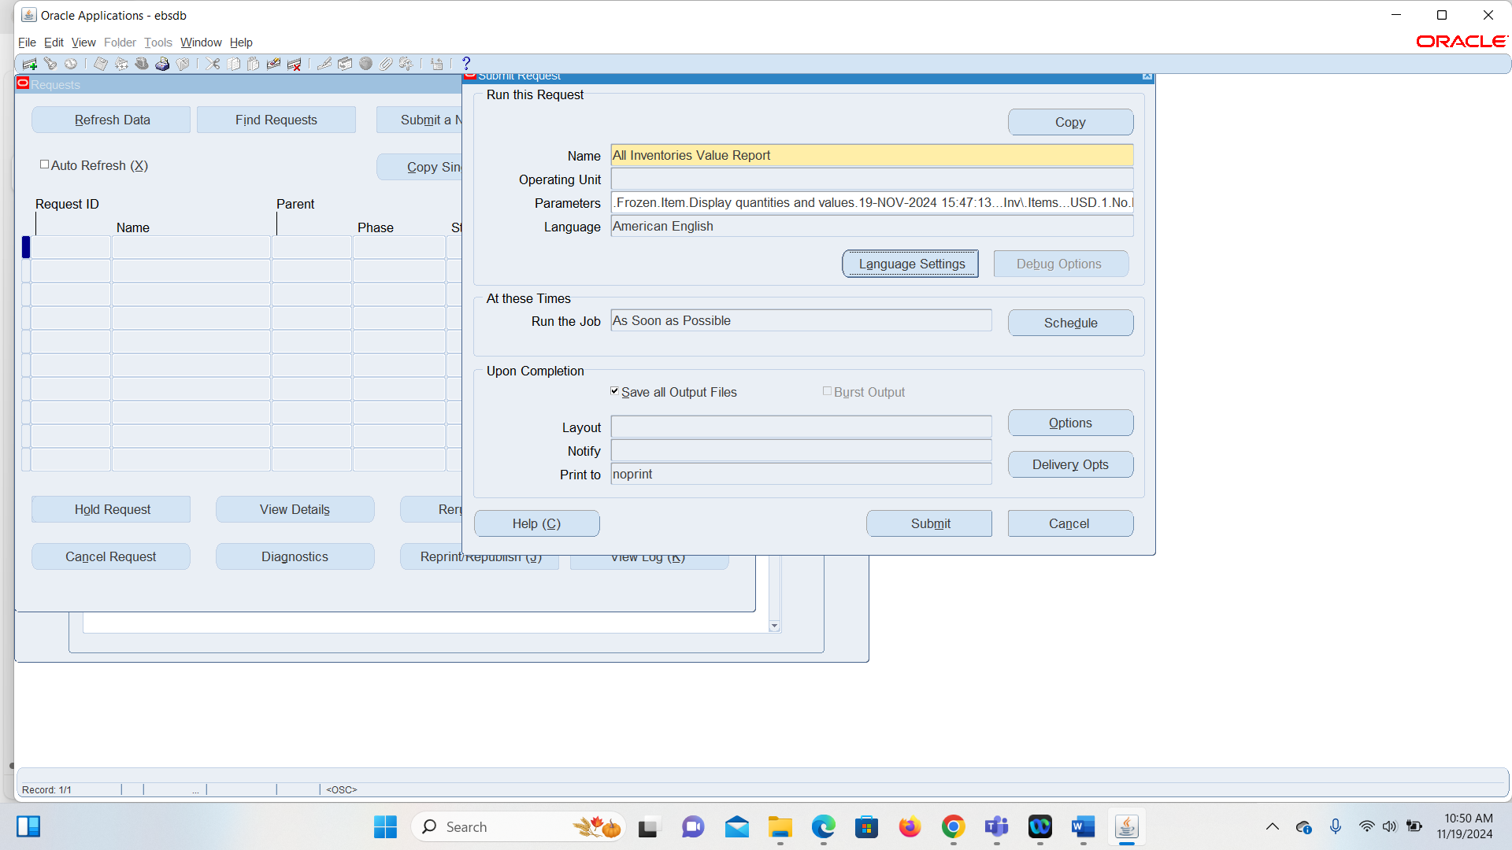

The parameters would then pop up and then after that you can click on submit and then your request ID will show up

You click on No, and then you can submit

Once you submit, it takes you to this window

10. How to change Inventory Organization in the Current responsibility.

You would navigate from Inventory>Change Organization

After you click on Change Organization it will take you to a menu where you then can choose from a list of inventory organizations.

11. What is **Master Data** in Oracle Inventory?

This is several pieces of data that is created in the inventory responsibility. It is used to maintain consistency and data integrity throughout the application.

Master Data uses several oracle modules that are used for data and is used in many different transactions. Som examples of this are Description, Units of Measure, Costing Methods, stocking type and item categories.

12.Show the existing ORG with navigation.

Once you get here you go to Inventory > Setup > Organizations > Organizations

In the Find Organizations form after you click on Vision Operations in the navigation.

Once you click on Find for Vision Operations then this window will come up.

13: You can manage only finished goods in **Oracle Inventory**?

Since Oracle Inventory is flexible, it is not limited to only finished goods. It’s designed to handle various types of inventory including but not limited to finished goods. You can manage Raw Materials, Work-In-Progress items, Finished Goods. Maintenance, Repair, and Operations Items. Expense items.

14. You need to create an item before performing inventory transactions  **[True/False].**

True because a Master Item has to be made before making any sort of inventory transaction

15. Sub inventories are optional in Oracle Inventory. **[Ture/False].**

True, because they help manage and track inventory like physical items more efficiently.